SEMESTER 1
ARDUINO PROGRAMMING BASICS AND
INTRODUCTION TO EMBEDDED CONTROL


Module Overview
This module builds a complete, practical foundation in Arduino programming — starting with what a microcontroller is and how to set up the Arduino IDE, then moving through program structure, data types, conditions, loops, and the Serial Monitor, and finally applying every concept to control real outputs: an LED, a buzzer and a DC motor. Every topic is taught in the sequence Learn → See → Do → Check → Build, and every section adds one working piece to a single capstone project, the SmartAlert Station. Labs are run first in a free browser simulator (Wokwi or Tinkercad Circuits) and then on real hardware, so learners can practise safely before wiring a board. The topics are organised as self-contained sections rather than fixed time slots, so pace can flex per batch; taught end-to-end with the hands-on labs, the full set is designed to fill approximately 36 hours of instruction.

# | Topic | Hands-on Focus
1 | Introduction to Arduino & IDE Setup | Lab: Blink an external LED
2 | Program Structure & the Serial Monitor | Lab: Heartbeat LED with serial control
3 | Variables & Data Types | Lab: Type explorer and uptime counter
4 | Conditions — Making Decisions | Lab: Traffic light with buzzer alarm
5 | Loops, PWM & Non-blocking Timing | Lab: Fade, blink and melody at once
6 | DC Motor Control & State Machines | Lab: Smart Fan (guided project)
7 | Independent Engineering Challenges | Solve 3 of 5 challenges from a spec
8 | Capstone — SmartAlert Station | Build, test, document and present
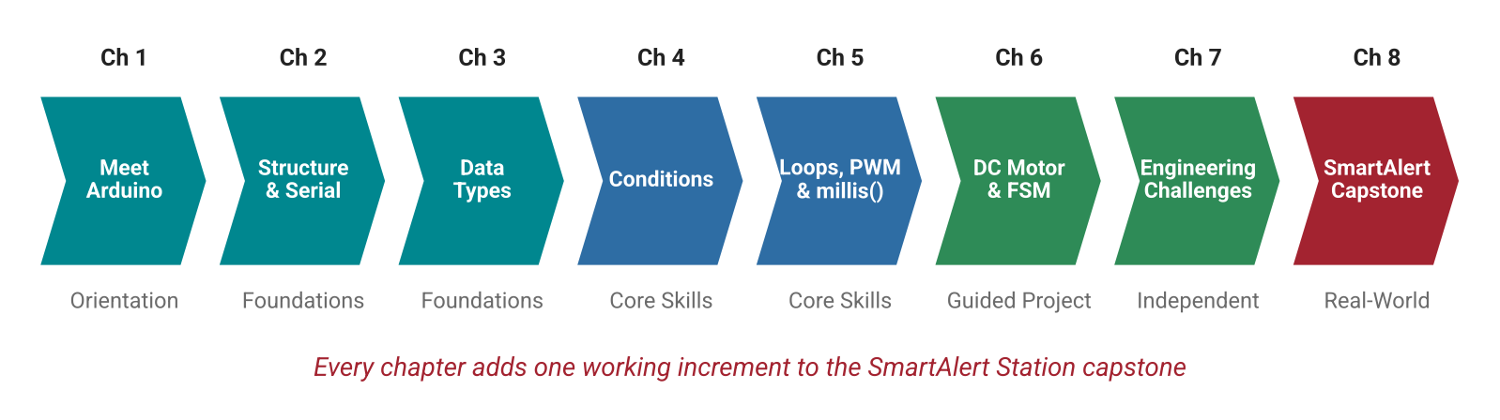
Figure 0.1: Module roadmap — from orientation to a portfolio-ready capstone project.

Learning Outcomes
On completing this module, the learner will be able to:
# | Learning Outcome | Evidence
LO1 | Explain how a microcontroller reads inputs, runs code and drives outputs | Labelled board diagram, quiz
LO2 | Configure Arduino IDE 2.x and upload a verified sketch to a board | Lab 1 upload proof
LO3 | Identify the parts of a sketch and trace its execution order | Code-tracing exercise
LO4 | Select correct data types and predict overflow and rounding errors | Lab 3, Debug Clinic
LO5 | Implement decisions with if / else and switch to react to inputs | Lab 4
LO6 | Build repetition with loops and replace delay() with millis() | Lab 5
LO7 | Use the Serial Monitor and Plotter to print, parse commands and debug | Debug Clinic log
LO8 | Wire and control an LED, a buzzer and a DC motor safely | Lab 6 demo
LO9 | Design and integrate a multi-output system using a state machine | Capstone
LO10 | Document and present an embedded project and relate it to IoT and Edge AI roles | GitHub repo, pitch

Hardware & Software Required
Item | Qty | Purpose
Arduino Uno R3 / Uno R4 Minima (or compatible) + USB cable | 1 | Main board, power and upload
Breadboard (830 points) and jumper wires | 1 set | Prototyping without soldering
LEDs (red, yellow, green) + 220 Ω resistors | 5 each | Visual output
Passive buzzer (and optional active buzzer) | 1 | Sound output
Push buttons | 2 | Digital input
10 kΩ potentiometer | 1 | Analog input / simulated sensor
Small 5–6 V DC motor | 1 | Actuation
NPN transistor (TIP120 or 2N2222) + 1 kΩ resistor | 1 | Motor switching
1N4007 diode | 1 | Flyback protection
4×AA battery pack or 5–6 V supply | 1 | Separate motor power

- Arduino IDE 2.x — code editor with Serial Monitor, Serial Plotter and Library Manager (free).
- Wokwi (wokwi.com) or Tinkercad Circuits — browser simulators used to test every lab before wiring.
- Git + GitHub — version control and the portfolio home for the capstone project.

1. Introduction to Arduino & Microcontrollers

1.1 What Is a Microcontroller?
A microcontroller (MCU) is a complete small computer on a single chip: it contains a processor, memory for the program (Flash), memory for variables (SRAM) and a set of input/output pins. Unlike a laptop that runs many applications on an operating system, a microcontroller runs one program, continuously, from the moment it is powered on. Microcontrollers are hidden inside washing machines, TV remotes, microwave ovens, smart watches, cars, drones and industrial machines.
Every microcontroller program follows the same pattern: it reads inputs (buttons, sensors), processes them using the logic you write, and drives outputs (LEDs, buzzers, motors). Think of it as a chef following one recipe forever — ingredients arrive (inputs), the recipe is applied (process), and dishes are served (outputs).
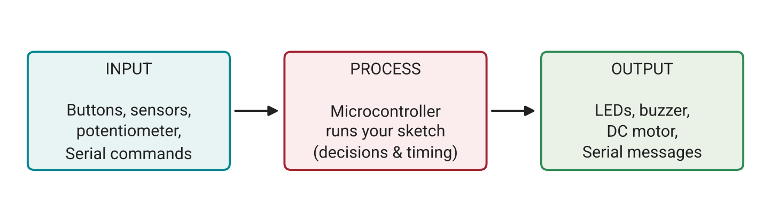
Figure 1.1: The Input → Process → Output model that every Arduino sketch follows.

1.2 Why Arduino for This Module?
- Beginner-friendly — the Arduino language is simplified C++ with ready-made functions such as digitalWrite() and analogRead().
- Low cost and robust — a complete starter kit costs very little, and the Uno tolerates common beginner mistakes.
- Simulator support — every lab can be run in Wokwi or Tinkercad before touching hardware.
- Huge ecosystem — thousands of libraries, shields and tutorials, and the same skills transfer to ESP32, STM32 and other boards used in industry.
- Industry bridge — Arduino-class boards act as the “hands” of IoT and Edge AI systems, switching outputs based on what sensors or vision models detect.

1.3 The Arduino Uno Board
The Arduino Uno is built around the ATmega328P microcontroller, running at 16 MHz with 32 KB of Flash and 2 KB of SRAM. Knowing where each group of pins sits is the first step to wiring correctly.
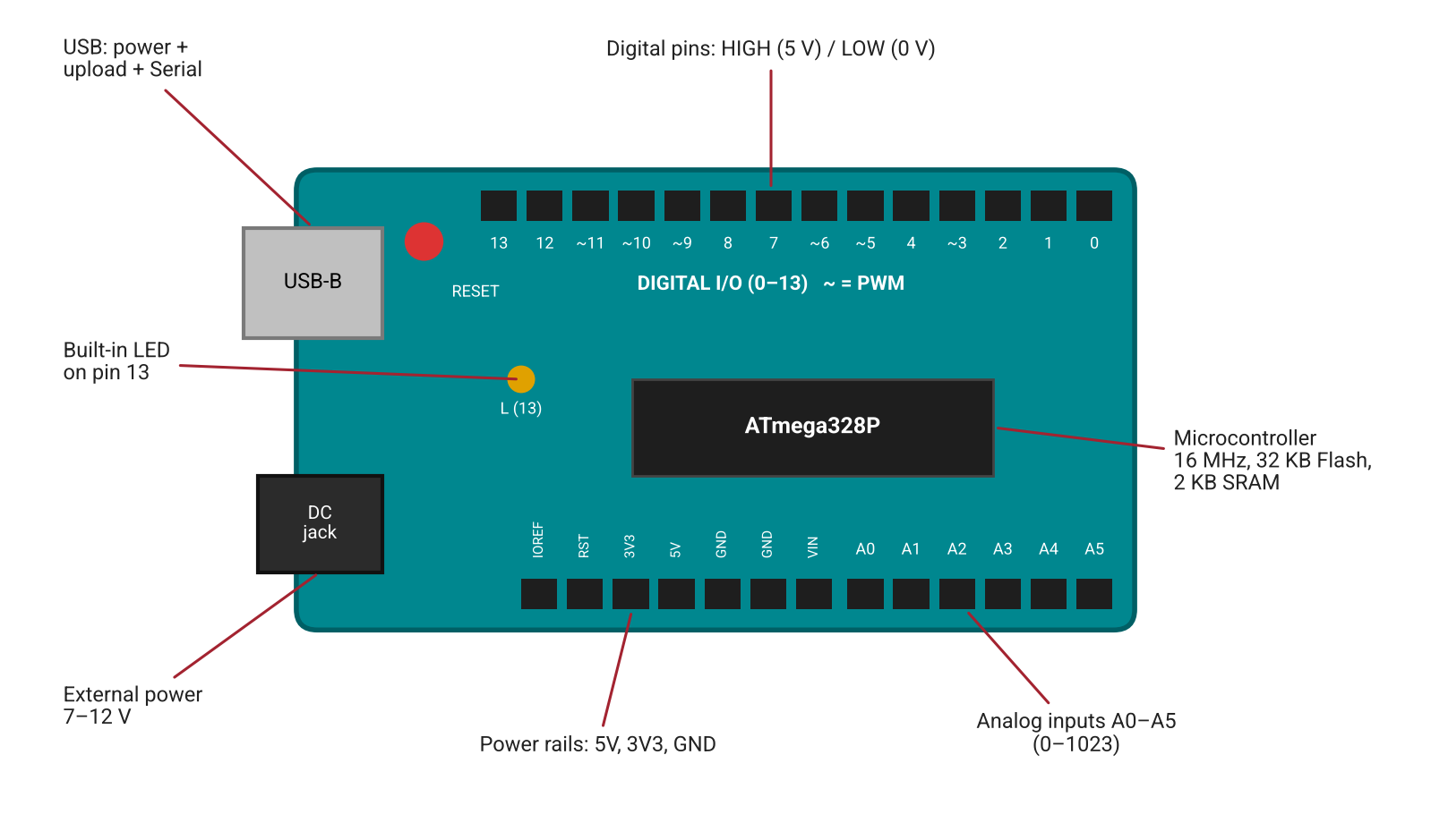
Figure 1.2: Arduino Uno layout showing digital pins, PWM pins (~), analog inputs, power rails and the USB port.
Pin Group | Pins | Used For
Digital I/O | D0 – D13 | Reading buttons, switching LEDs and buzzers ON/OFF
PWM (~) | 3, 5, 6, 9, 10, 11 | Dimming LEDs, controlling motor speed with analogWrite()
Analog Inputs | A0 – A5 | Reading potentiometers and sensors (0 – 1023)
Power | 5V, 3V3, GND, VIN | Powering small components; GND is the common reference
Serial | D0 (RX), D1 (TX), USB | Communication with the PC — keep D0/D1 free
Built-in LED | D13 (“L”) | Quick tests without any wiring

1.4 Electrical Survival Basics
Three quantities describe every circuit: voltage (V) is electrical pressure, current (I) is the flow of charge, and resistance (R) limits that flow. They are linked by Ohm’s law, V = I × R. An Arduino pin outputs 5 V but should supply no more than about 20 mA (40 mA is the absolute maximum), so every LED needs a series resistor.
- Resistor for an LED: R = (5 V − 2 V LED drop) ÷ 0.015 A ≈ 200 Ω → use the standard 220 Ω.
- LED polarity: the long leg (anode, +) goes toward the pin; the short leg (cathode, −) goes toward GND.
- Breadboard: holes in each short row of five are connected; the long side rails run the full length and are used for 5V and GND.
- Never connect 5V directly to GND, and never drive a motor directly from a pin (see Section 6).
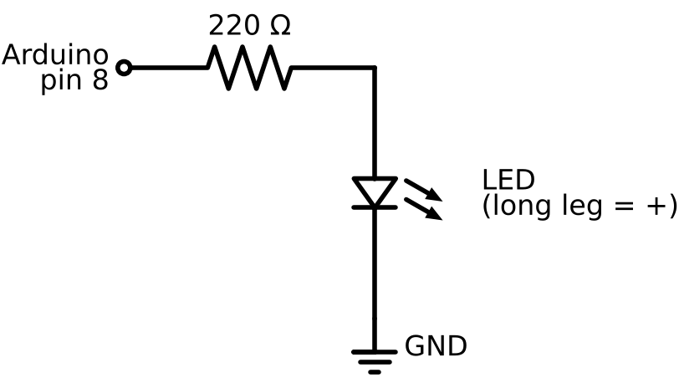
Figure 1.3: LED circuit used in Lab 1 — pin 8 drives the LED through a 220 Ω current-limiting resistor.

1.5 Arduino IDE 2.x Setup & First Upload
The Arduino IDE translates (compiles) your C++ sketch into machine code and uploads it over USB into the board’s Flash memory. Before every upload, the correct Board and Port must be selected from the Tools menu.
- Download and install Arduino IDE 2.x from the official Arduino website.
- Connect the Uno with a data-capable USB cable (some cables are charge-only).
- Select Tools → Board → Arduino Uno and Tools → Port (COMx on Windows, /dev/cu.usbmodem… on macOS, /dev/ttyACM0 on Linux).
- Open File → Examples → 01.Basics → Blink.
- Click Verify (✓) to compile, then Upload (→). Wait for “Done uploading”.
- Confirm the on-board “L” LED blinks once per second.
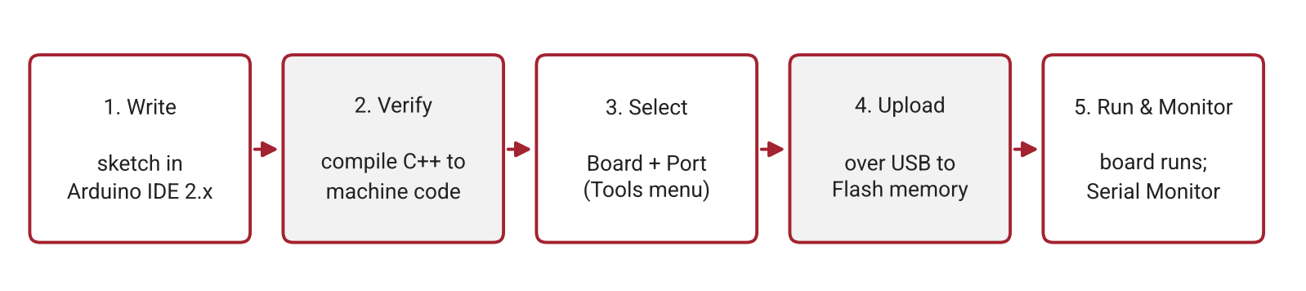
Figure 1.4: The five-step development workflow repeated for every lab in this module.

1.6 Common Mistakes
Mistake | What Happens | How to Avoid
LED inserted backwards | LED never lights | Long leg toward the pin, short leg to GND
No series resistor | LED or pin damaged | Always use 220 Ω with a 5 V pin
Port greyed out | Upload fails | Use a data cable; install CH340 driver for clones
Wrong board selected | Upload/compile errors | Tools → Board → Arduino Uno
Both LED legs in one row | LED shorted, stays off | Place the legs in different breadboard rows

Lab Exercise 1: Blinking an External LED
Objective
To configure the Arduino IDE, build a simple LED circuit, upload a first sketch and modify its timing — first in the Wokwi simulator and then on real hardware.
Hardware Required
- Arduino Uno + USB cable
- Breadboard and jumper wires
- 1 × LED and 1 × 220 Ω resistor
Software Required
- Arduino IDE 2.x
- Wokwi (browser simulator)
Working Principle
pinMode() configures pin 8 as an output. digitalWrite(HIGH) places 5 V on the pin so current flows through the resistor and LED; digitalWrite(LOW) places 0 V and the LED turns off. delay() pauses the program for the given number of milliseconds, creating the visible blink.
Circuit Connections
Component | Arduino Pin
LED anode (long leg) via 220 Ω | D8
LED cathode (short leg) | GND
Procedure
- Create a new Wokwi Arduino Uno project and wire the circuit shown in Figure 1.3.
- Type the program below and start the simulation; confirm the LED blinks every 0.5 s.
- Build the same circuit on the breadboard and upload the sketch to the real board.
- Change both delays to 250 ms and observe the faster blink.
- Change the ON time to 100 ms and the OFF time to 900 ms; describe the visual difference.
- Independent task: make the LED flash SOS (· · · — — — · · ·) using only digitalWrite() and delay().
Program Code
// Lab 1: External LED blink
const int LED_PIN = 8; // LED + 220 ohm resistor to GND

void setup() {
pinMode(LED_PIN, OUTPUT); // configure the pin as an output once
}

void loop() {
digitalWrite(LED_PIN, HIGH); // 5 V -> LED on
delay(500); // wait 500 ms
digitalWrite(LED_PIN, LOW); // 0 V -> LED off
delay(500);
}
Expected Output
The LED connected to pin 8 turns on for 500 ms and off for 500 ms continuously, both in the simulator and on the hardware. The IDE output panel shows “Done uploading”.
Observation
Changing the delay values directly changes the blink rate and the ratio of ON to OFF time. If the LED does not light, the most likely causes are reversed polarity, a missing GND connection or the wrong pin number in the code.
Conclusion
The learner has completed the full development workflow — wiring, writing, verifying, uploading and testing — and has created the GitHub repository smartalert-station with the capstone problem statement as its first commit.

Quick Check
- A smoke alarm beeps when smoke is detected. Name its input, process and output.
- Which Uno pins can produce PWM?
- Why does an LED need a series resistor?
- An upload fails with “port not found”. List two things to check.

2. Program Structure & the Serial Monitor

2.1 Anatomy of a Sketch
Every Arduino program (called a sketch) follows the same skeleton. Global declarations at the top — constants, variables and #include lines — are set up first. The setup() function runs once after power-on or reset, and is used for configuration such as pinMode() and Serial.begin(). The loop() function then runs forever, top to bottom, thousands of times per second. Statements end with a semicolon, blocks are enclosed in braces { }, and the language is case-sensitive (digitalwrite is not the same as digitalWrite).
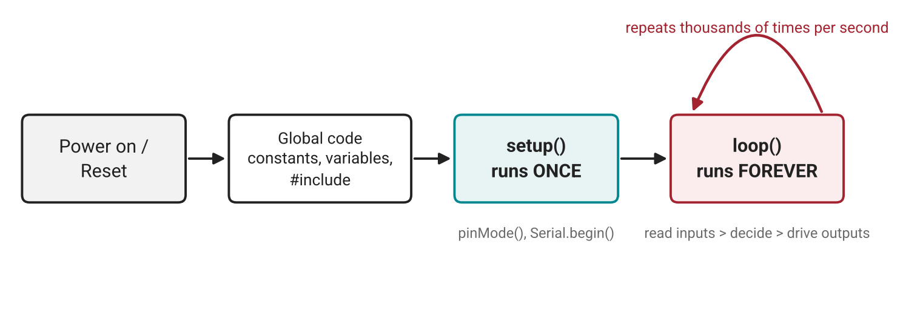
Figure 2.1: Execution order of every Arduino sketch — setup() once, then loop() forever.

2.2 Functions & Comments
A function packages a task under a meaningful name so it can be reused. Parameters pass data in and return sends a result back; void means the function returns nothing. Comments (// for one line, /* … */ for several) should explain why the code does something. As projects grow, functions are what keep the code readable — the capstone has around 200 lines and would be unmanageable without them.
void blinkTimes(int pin, int times, int ms) { // reusable task
for (int i = 0; i < times; i++) {
digitalWrite(pin, HIGH); delay(ms);
digitalWrite(pin, LOW); delay(ms);
}
}

int doubleIt(int x) { return x * 2; } // returns a value

2.3 The Serial Monitor & Serial Plotter
The board has no screen, so the USB serial link becomes its voice. The Serial Monitor shows text sent by the board and lets you type commands back to it; the Serial Plotter draws numbers as live graphs. Both sides must use the same baud rate (speed) — a mismatch produces unreadable characters.
Function | What It Does
Serial.begin(115200) | Opens the serial link at 115200 baud (call once in setup)
Serial.print(x) | Sends text or a value without a new line
Serial.println(x) | Sends text or a value followed by a new line
Serial.available() | Returns how many received characters are waiting
Serial.read() | Reads one received character
F("text") | Keeps fixed text in Flash memory to save RAM
label:value pairs | Printed one line at a time, they appear as named curves in the Serial Plotter
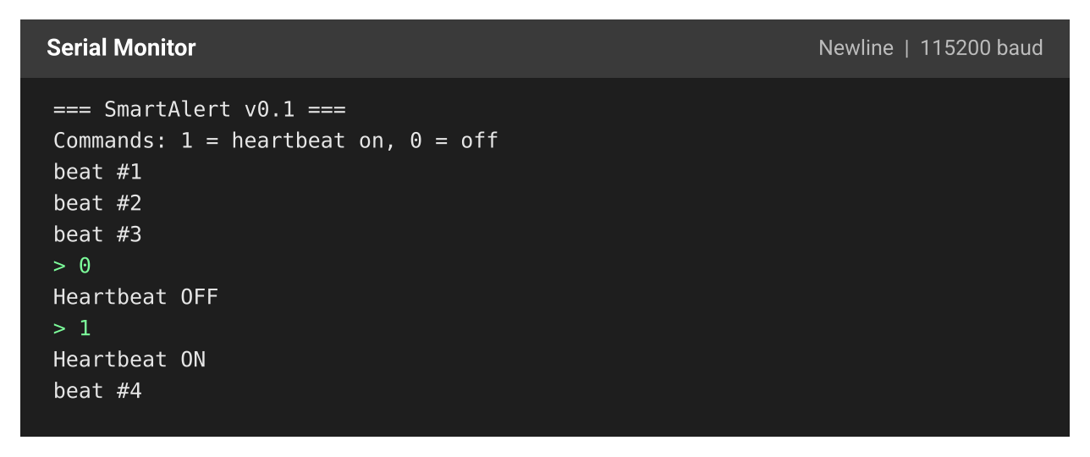
Figure 2.2: Serial Monitor output from Lab 2 — boot banner, heartbeat count and command responses.

2.4 Common Mistakes
Mistake | What Happens | How to Avoid
Missing ; or } | Compile error | Read the first error line; check the line above it
Baud rate mismatch | Garbage characters | Match Serial.begin() and the monitor setting
Forgetting Serial.begin() | Nothing is printed | Always call it in setup()
Variable declared inside loop() | Value resets every pass | Declare it globally or as static
Line ending sends \n | Extra unknown command | Ignore '\n' and '\r' in the parser

Lab Exercise 2: Heartbeat LED with Boot Log and Serial Control
Objective
To combine custom functions with the Serial Monitor: the board prints a boot banner, shows a heartbeat on an LED, counts beats, and accepts commands typed by the user.
Hardware Required
- Arduino Uno, breadboard, 1 × LED, 1 × 220 Ω resistor (LED on pin 8)
Software Required
- Arduino IDE 2.x (Serial Monitor set to 115200 baud)
- Wokwi
Working Principle
setup() opens the serial link and prints a banner once. In loop(), handleSerial() checks for typed characters: ‘1’ enables and ‘0’ disables the heartbeat. When enabled, heartbeat() flashes the LED twice and the beat counter is printed.
Procedure
- Wire the LED to pin 8 and upload the program below.
- Open the Serial Monitor at 115200 baud and read the banner.
- Type 0 and press Enter — the heartbeat stops. Type 1 to restart it.
- Notice that the response to a command is sometimes slow; write down why (hint: delay). This problem is solved in Section 5.
- Add a command ‘2’ that prints the current beat count.
- Debug Clinic: fix the planted bugs supplied by the instructor (wrong baud rate, missing brace, lowercase serial.println) and log each as symptom → cause → fix.
Program Code
// Lab 2: Heartbeat + boot log + serial control
const int LED_PIN = 8;
bool ledEnabled = true;
unsigned long beatCount = 0;

void printBanner() {
Serial.println(F("=== SmartAlert v0.1 ==="));
Serial.println(F("Commands: 1 = heartbeat on, 0 = off"));
}

void heartbeat() { // two quick pulses, like a heartbeat
for (int i = 0; i < 2; i++) {
digitalWrite(LED_PIN, HIGH); delay(100);
digitalWrite(LED_PIN, LOW); delay(150);
}
delay(600);
}

void handleSerial() {
if (Serial.available() > 0) {
char c = Serial.read();
if (c == '1') { ledEnabled = true; Serial.println(F("Heartbeat ON")); }
if (c == '0') { ledEnabled = false; Serial.println(F("Heartbeat OFF")); }
}
}

void setup() {
pinMode(LED_PIN, OUTPUT);
Serial.begin(115200);
printBanner();
}

void loop() {
handleSerial();
if (ledEnabled) {
heartbeat();
beatCount++;
Serial.print(F("beat #"));
Serial.println(beatCount);
}
}
Expected Output
The Serial Monitor shows the banner followed by “beat #1”, “beat #2” … while the LED double-flashes. Typing 0 prints “Heartbeat OFF” and the LED stays dark; typing 1 resumes it (Figure 2.2).
Observation
Commands are only processed between heartbeats, because delay() freezes the processor for about 1 s each cycle. The Serial Monitor proved to be both a user interface and a debugging tool.
Conclusion
The learner can structure a sketch with functions and communicate with the board in both directions. The printBanner() function and status logger become the first code in the SmartAlert project.

Quick Check
- Code in setup() runs (a) once (b) forever (c) only when a button is pressed?
- What does void mean in void setup()?
- You see “ÿþ¬” in the Serial Monitor. What is the most likely cause?

3. Variables & Data Types

3.1 Variables, Constants & Scope
A variable is a labelled box in memory that holds a value which can change while the program runs; it is declared as type name = value;. A constant (const int LED_PIN = 8;) cannot change, and the compiler protects it — using named constants instead of “magic numbers” scattered through the code makes changes safe and code readable. Scope defines where a variable is visible: a variable declared inside braces exists only there, a global variable lives for the whole program, and a static local variable keeps its value between function calls.

3.2 Choosing the Right Data Type
On the Uno, an int is only 16 bits (2 bytes), which surprises programmers who are used to computers. Choosing the wrong type causes some of the strangest bugs — timers that stop after half a minute or averages that always round down.
Type | Size | Range / Typical Use
bool | 1 byte | true / false — states and flags
byte / uint8_t | 1 byte | 0 – 255 — PWM values, small counts
char | 1 byte | One character — serial commands
int | 2 bytes | −32,768 to 32,767 — pins, small counts
unsigned int | 2 bytes | 0 – 65,535
long | 4 bytes | ±2.1 billion
unsigned long | 4 bytes | 0 – 4.29 billion — always used for millis()
float | 4 bytes | Decimals with 6–7 digits — voltages, temperatures
String / char[] | varies | Text — prefer F() and char arrays for fixed text
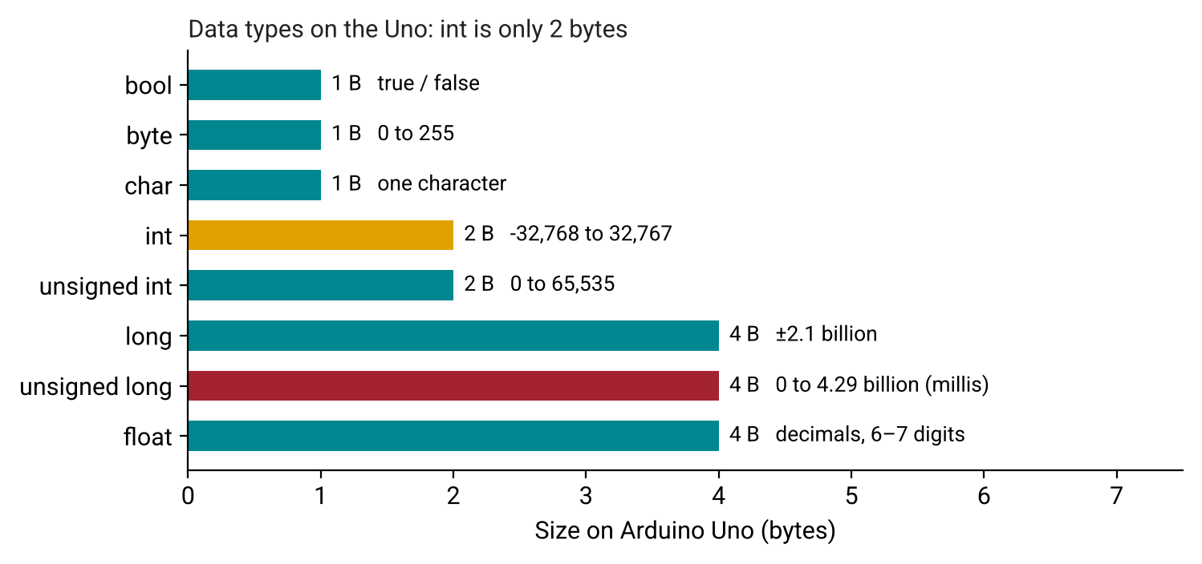
Figure 3.1: Memory size of each data type on the Arduino Uno.

3.3 Arithmetic, Casting & Overflow
Integer division discards the remainder: 7 / 2 gives 3, while 7 % 2 (modulo) gives the remainder 1. Writing 7 / 2.0 forces floating-point maths and gives 3.5. A cast such as (float)reading converts a value explicitly. map(value, 0, 1023, 0, 255) rescales one range to another and constrain(x, lo, hi) clamps a value. When a value exceeds its type’s maximum it overflows and wraps around to the minimum — an int holding milliseconds goes negative after about 32.8 seconds.
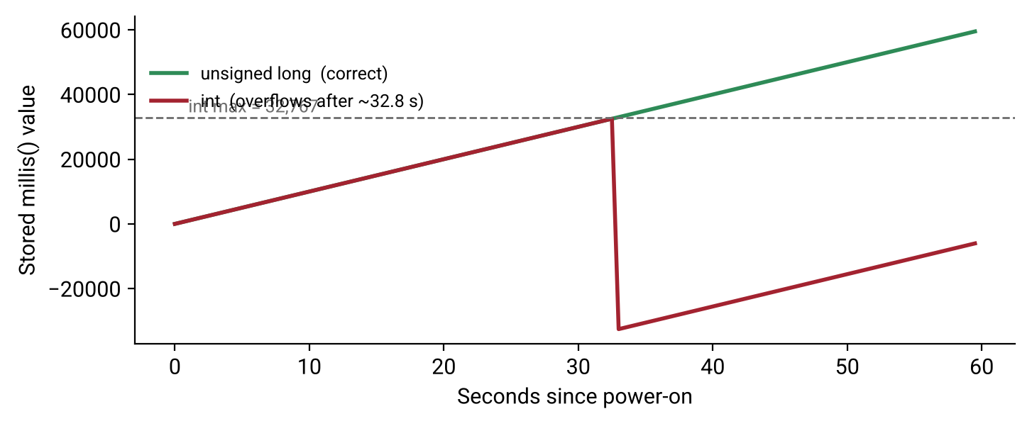
Figure 3.2: An int timer overflows after ~32.8 s, while unsigned long keeps counting correctly.

3.4 Common Mistakes
Mistake | What Happens | How to Avoid
Storing millis() in int | Timer breaks after ~32 s | Use unsigned long for all time values
raw * 5 / 1023 | Only 0 – 4 V is shown | Use 5.0 and 1023.0 to force float maths
if (x = 5) | Always true; x is changed | Use == for comparison
Magic numbers | Hard to change safely | Put pins and thresholds in named constants
int accumulator for averages | Result is rounded | Use float or long and cast

Lab Exercise 3: Data Type Explorer and Uptime Counter
Objective
To observe overflow and precision errors directly in the Serial Plotter, correct them by choosing proper data types, and convert a potentiometer reading into volts and a PWM value.
Hardware Required
- Arduino Uno, breadboard, 10 kΩ potentiometer (middle pin to A0, outer pins to 5V and GND)
Software Required
- Arduino IDE 2.x (Serial Monitor and Serial Plotter)
- Wokwi
Working Principle
analogRead() converts the potentiometer voltage into a number from 0 to 1023. The sketch converts it three ways — correct float volts, incorrect integer volts and a map()-scaled PWM value — while an intentionally undersized int counter demonstrates overflow.
Procedure
- Wire the potentiometer and upload the program below.
- Open the Serial Plotter and turn the potentiometer slowly from end to end.
- Record when badSeconds turns negative and explain why.
- Fix the overflow by choosing the correct data type, then re-test.
- Explain why the “wrong” trace only shows the values 0 to 4.
- Mini-project: build a Battery Gauge that prints 0–100 % and lights the LED below 20 %.
Program Code
// Lab 3: Type explorer + pot readings + uptime
const int POT_PIN = A0;
int badSeconds = 32700; // will overflow - intentional
unsigned long lastPrint = 0;

void setup() {
Serial.begin(115200);
Serial.print(F("sizeof int: ")); Serial.println(sizeof(int));
Serial.print(F("sizeof long: ")); Serial.println(sizeof(long));
Serial.print(F("sizeof float: ")); Serial.println(sizeof(float));
}

void loop() {
int raw = analogRead(POT_PIN); // 0..1023
float volts = raw * 5.0 / 1023.0; // float math
int wrongVolts = raw * 5 / 1023; // integer math bug
byte pwm = map(raw, 0, 1023, 0, 255); // rescale

Serial.print(F("raw:")); Serial.print(raw);
Serial.print(F(" volts:")); Serial.print(volts, 2);
Serial.print(F(" wrong:")); Serial.print(wrongVolts);
Serial.print(F(" pwm:")); Serial.println(pwm);

badSeconds += 50; // watch it go negative
Serial.print(F("badSeconds:")); Serial.println(badSeconds);

Serial.print(F("uptime_s:")); Serial.println(millis() / 1000UL);
delay(500);
}
Expected Output
The program first prints the size of each type (int = 2, long = 4, float = 4). The plotter then shows smooth volts (0.00 – 5.00), a stepped “wrong” value (0 – 4) and PWM (0 – 255) as the potentiometer turns; badSeconds jumps from 32,750 to a large negative number after a few readings.
Observation
Integer arithmetic silently loses precision and int silently wraps around — neither produces an error message, which is why choosing types deliberately matters.
Conclusion
The learner can choose types by range, sign and precision. All SmartAlert pins, timings and thresholds are now collected in one typed configuration block.

Quick Check
- Why does int count = 0; declared inside loop() never get past 1?
- Which type should store millis(), and why?
- What does int v = 512 * 5 / 1023; store? (Answer: 2)

4. Conditions — Making Decisions

4.1 Digital Input — Reading Buttons
An input pin that is not connected to anything “floats” and reads random HIGH/LOW values. Setting pinMode(pin, INPUT_PULLUP) enables an internal resistor to 5 V, so the pin reads HIGH when released and LOW when pressed (with the button wired to GND). This is called active-low logic. Mechanical buttons also bounce — their contacts chatter for 5–20 ms — so one press can be counted several times unless it is debounced.
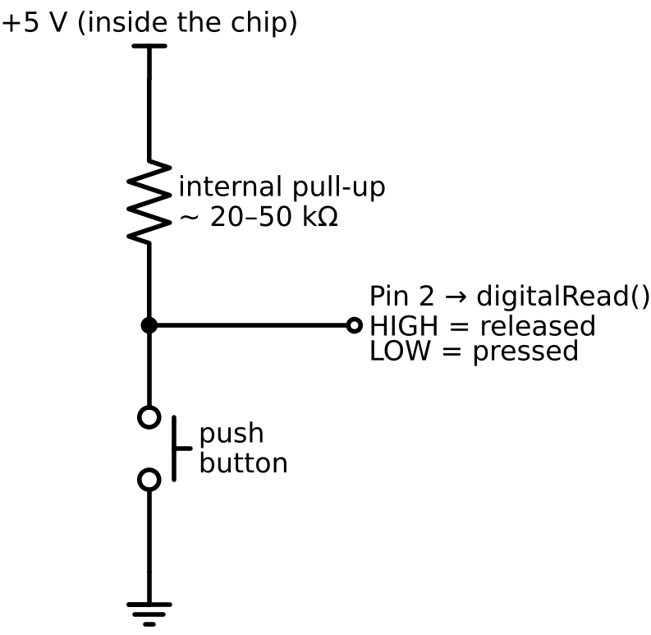
Figure 4.1: Button wired with the internal pull-up resistor — pressing it pulls pin 2 to GND.

4.2 if / else if / else & Logical Operators
Conditions let a device react. In an if / else if / else chain, only the first true branch runs, so the most specific case is checked first. Comparisons and logical operators build the conditions:
Operator | Meaning | Example
== != | equal / not equal | if (mode == 'r')
< > <= >= | less / greater than | if (temp >= 40)
&& | AND — both must be true | if (hot && fanOff)
|| | OR — either may be true | if (btn || tooHot)
! | NOT — flips true/false | if (!muted)
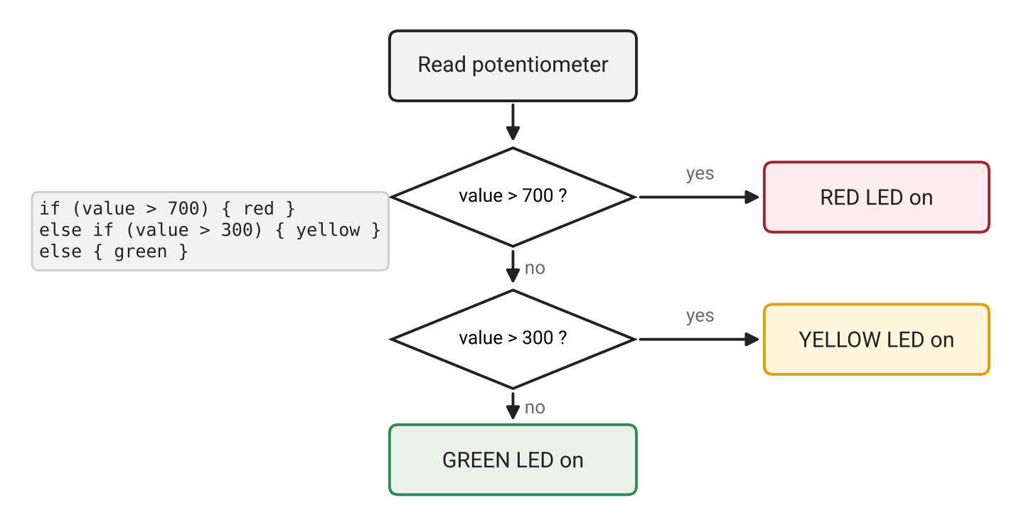
Figure 4.2: Decision flow for the potentiometer level indicator built in Section 4.

4.3 switch-case & Serial Commands
When one variable must be compared against several exact values — such as single-character serial commands — switch is clearer than a long if-chain. Each case must end with break, otherwise execution “falls through” into the next case; default handles anything unexpected. A switch works on char and int values, not on String.

4.4 Sound Output — The Buzzer
Type | How It Works | How to Drive It
Active buzzer | Built-in oscillator, one fixed tone | digitalWrite(pin, HIGH)
Passive buzzer | Needs a square wave; any pitch | tone(pin, freq, ms) and noTone(pin)

tone(7, 1000) produces a 1 kHz note; higher frequency means higher pitch. Only one tone can play at a time, and on the Uno tone() disables PWM on pins 3 and 11 — so LEDs and motors should use other PWM pins.

4.5 Common Mistakes
Mistake | What Happens | How to Avoid
pinMode(BUTTON, INPUT) | Phantom presses | Use INPUT_PULLUP
Expecting HIGH when pressed | Logic is inverted | Pressed = LOW with pull-up
Missing break in switch | Several cases run | End every case with break
if (300 < x < 700) | Always true | Write (x > 300 && x < 700)
Button rotated 90° | Always connected | Place it across the breadboard gap

Lab Exercise 4: Traffic Light with Pedestrian Alarm
Objective
To combine digital input, if / else decisions, switch-case serial commands and buzzer output in a single traffic-light controller.
Hardware Required
- Arduino Uno and breadboard
- Red, yellow and green LEDs with 220 Ω resistors
- 1 × push button, 1 × passive buzzer
Circuit Connections
Component | Arduino Pin
Red LED | D10
Yellow LED | D9
Green LED | D6
Push button (other leg to GND) | D2
Passive buzzer (+) | D7
Working Principle
In auto mode the lights cycle green → yellow → red. While red, the button is checked; a press sounds a two-tone pedestrian alarm. Typing r, y or g in the Serial Monitor forces a manual override, and a returns to auto mode.
Procedure
- Wire the circuit and upload the program below (simulate in Wokwi first).
- Observe the auto cycle and press the button during red.
- Press the button during green and record the delay before a response in five trials.
- Send r, y, g and a from the Serial Monitor and verify each mode.
- Debug Clinic: fix the planted bugs — if (mode = 'r'), a missing break and pinMode(BUTTON, INPUT).
- Mini-project: Door-Ajar Alarm — warning beep after 5 s open, continuous alarm and red LED after 10 s.
Program Code
// Lab 4: Traffic light + pedestrian button + serial override
const int RED = 10, YELLOW = 9, GREEN = 6;
const int BUTTON = 2, BUZZER = 7;
char mode = 'a'; // a = auto, r/y/g = manual override

void setLights(bool r, bool y, bool g) {
digitalWrite(RED, r); digitalWrite(YELLOW, y); digitalWrite(GREEN, g);
}

void pedestrianAlarm() {
for (int i = 0; i < 3; i++) {
tone(BUZZER, 1200, 150); delay(250);
tone(BUZZER, 800, 150); delay(250);
}
}

void readCommand() {
if (Serial.available()) {
char c = Serial.read();
if (c == '\n' || c == '\r') return;
switch (c) {
case 'a': case 'r': case 'y': case 'g':
mode = c;
Serial.print(F("Mode: ")); Serial.println(mode);
break;
default:
Serial.println(F("Use a, r, y, g"));
}
}
}

void setup() {
pinMode(RED, OUTPUT); pinMode(YELLOW, OUTPUT); pinMode(GREEN, OUTPUT);
pinMode(BUTTON, INPUT_PULLUP);
Serial.begin(115200);
}

void loop() {
readCommand();
if (mode == 'r') setLights(1, 0, 0);
else if (mode == 'y') setLights(0, 1, 0);
else if (mode == 'g') setLights(0, 0, 1);
else { // auto cycle
setLights(0, 0, 1); delay(3000);
setLights(0, 1, 0); delay(1000);
setLights(1, 0, 0);
if (digitalRead(BUTTON) == LOW) { // pressed (active-low)
Serial.println(F("Pedestrian crossing"));
pedestrianAlarm();
}
delay(3000);
}
}
Expected Output
The LEDs cycle green (3 s) → yellow (1 s) → red (3 s). A button press during red prints “Pedestrian crossing” and plays three two-tone beeps. Serial commands switch to manual mode and print “Mode: r” etc.
Observation
Presses made during green or yellow are missed, because the button is only checked once per cycle while delay() blocks everything else. This limitation motivates the non-blocking techniques of Section 5.
Conclusion
The learner can make a device react to buttons, thresholds and commands. SmartAlert gains a fault button with an alarm tone and a first serial command parser (s = status, m = mute, ? = help).

Quick Check
- With INPUT_PULLUP, what does a pressed button read?
- Rewrite 300 < x < 700 correctly in C++.
- What happens if break is missing after case 'r'?
- Which buzzer type can play a melody?

5. Loops, PWM & Non-blocking Timing

5.1 for, while & do-while Loops
Loops repeat a block of code without copy-paste. In fact, loop() itself is an infinite loop provided by Arduino. Use for when the number of repetitions is known and while when repetition depends on a condition. A while that never becomes false freezes the board, so waits on sensors should include a timeout.
Loop | Checks Condition | Typical Use
for (int i = 0; i < 5; i++) | Before each pass | Known count — LED chasers, sweeps
while (cond) | Before each pass | Repeat while a button is held
do { } while (cond) | After each pass | Run at least once, e.g. a menu
break / continue | — | Exit early / skip to the next pass

5.2 PWM — Brightness & Speed Control
A digital pin can only be 0 V or 5 V. Pulse Width Modulation (PWM) switches the pin on and off very quickly (about 490 Hz, or 980 Hz on pins 5 and 6), and the duty cycle — the percentage of time the pin is ON — sets the average power delivered. analogWrite(pin, value) accepts 0 – 255, so 64 ≈ 25 %, 128 ≈ 50 % and 191 ≈ 75 %. It works only on pins marked ~, and it is exactly how LEDs are dimmed and motor speed is controlled in Section 6.
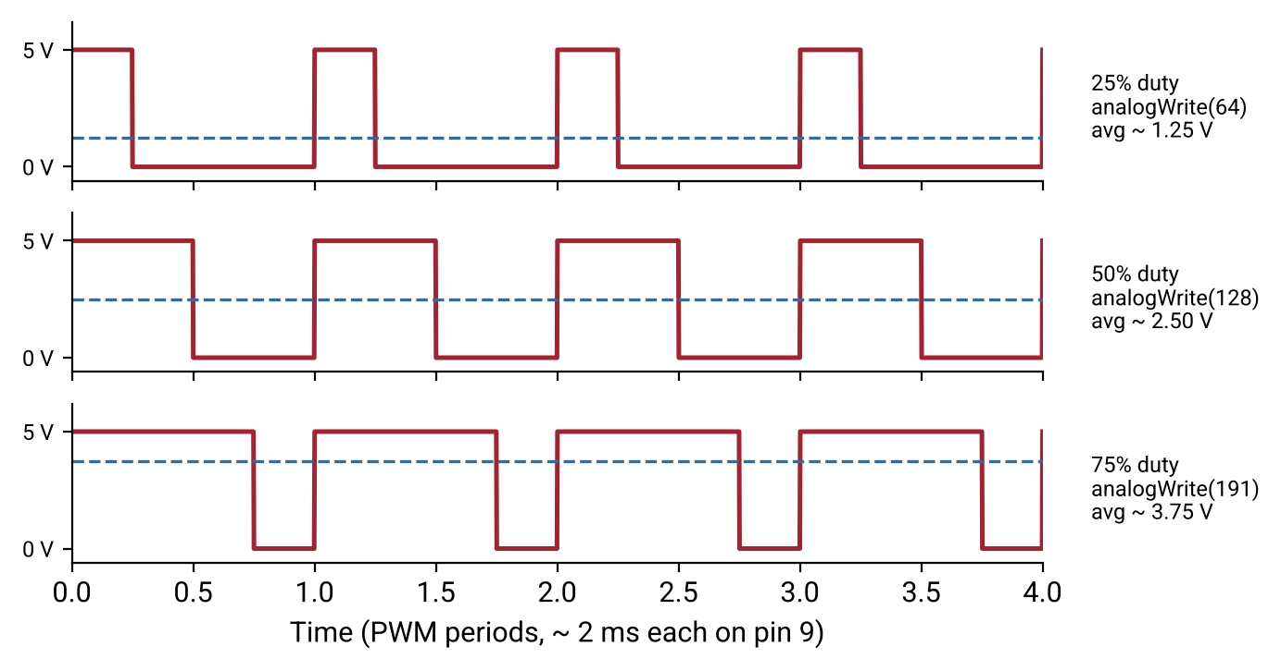
Figure 5.1: PWM signals at 25 %, 50 % and 75 % duty cycle and the average voltage each produces.

5.3 Arrays with Loops — Sequences & Melodies
An array stores several values of the same type under one name: int leds[] = {6, 9, 10};. Indexes start at 0, and the number of elements is sizeof(arr) / sizeof(arr[0]). A single for loop can then configure every LED or play every note of a melody stored in two parallel arrays (notes and durations). Reading past the end of an array produces garbage or crashes without any error message.

5.4 millis() — Doing Many Things at Once
delay() freezes the processor: nothing else can happen while it waits. millis() instead returns the number of milliseconds since power-on, so each task can keep its own timer and run only when its interval has passed. loop() then spins tens of thousands of times per second, checking every task in turn — the button is never ignored. This is the dividing line between beginner sketches and real firmware.
unsigned long lastBlink = 0; // always unsigned long
const unsigned long INTERVAL = 500;

void loop() {
unsigned long now = millis();
if (now - lastBlink >= INTERVAL) { // safe even when millis() wraps
lastBlink = now;
// do the task here
}
// ...check other tasks here - nothing is blocked
}
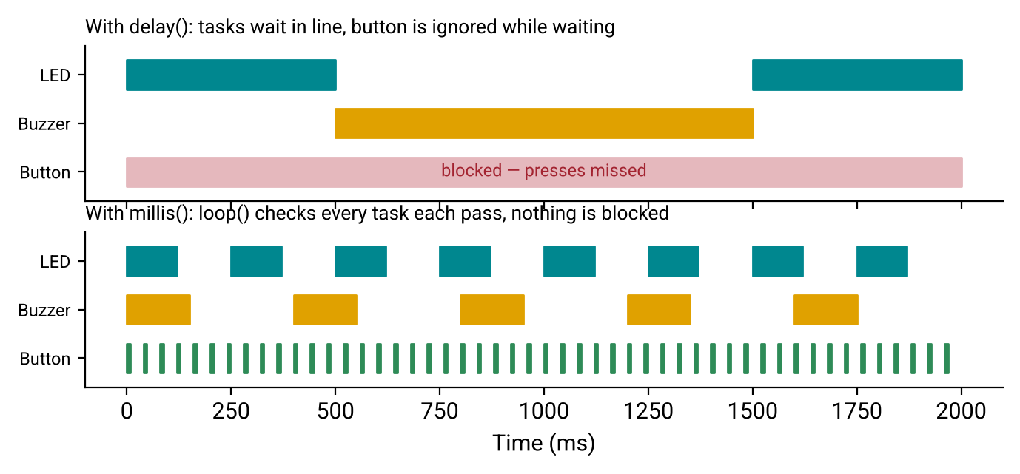
Figure 5.2: Blocking delay() versus non-blocking millis() scheduling of three tasks.

5.5 Common Mistakes
Mistake | What Happens | How to Avoid
Off-by-one (<= vs <) | Array read past the end | Loop while i < length
analogWrite on non-PWM pin | Only fully ON or OFF | Use pins 3, 5, 6, 9, 10, 11
Time stored in int | Task freezes after ~32 s | Use unsigned long
millis() > last + interval | Breaks after ~49.7 days | Use now - last >= interval
Mixing in a long delay() | Everything stutters | Remove all long delays from loop()

Lab Exercise 5: Breathing LED, Status Blink and Melody — All at Once
Objective
To run three independent tasks concurrently using millis() — a fading LED, a blinking status LED and an on-demand melody — while the serial command still responds instantly.
Hardware Required
- Arduino Uno and breadboard
- 2 × LEDs with 220 Ω resistors (pins 9 and 8)
- 1 × passive buzzer (pin 7)
Working Principle
Each task is a function with its own timestamp. updateFade() changes brightness by 5 every 20 ms using PWM, updateBlink() toggles the status LED every 500 ms, and updateMelody() steps through the notes array only when the current note has finished. Typing p starts the chime.
Procedure
- Wire the circuit and upload the program below.
- Confirm that the fade, the blink and the melody all run together.
- Add a fourth task that prints the uptime every 2 s.
- Count loop() passes per second and print the result (expect tens of thousands).
- Insert delay(200) at the end of loop(), observe how every task stutters, then remove it.
- Mini-project: Pomodoro Timer — breathing green LED for work, yellow for break, a chime at each switch, s to skip.
Program Code
// Lab 5: Non-blocking multitasking
const int FADE_LED = 9, STATUS_LED = 8, BUZZER = 7;
const int notes[] = {523, 659, 784, 1047}; // C5 E5 G5 C6
const int noteMs[] = {150, 150, 150, 300};
const int NUM_NOTES = sizeof(notes) / sizeof(notes[0]);

unsigned long lastFade = 0, lastBlink = 0, lastNote = 0;
int brightness = 0, step = 5;
bool statusOn = false;
int noteIndex = -1; // -1 = not playing

void updateFade(unsigned long now) {
if (now - lastFade >= 20) {
lastFade = now;
brightness += step;
if (brightness <= 0 || brightness >= 255) step = -step;
analogWrite(FADE_LED, constrain(brightness, 0, 255));
}
}

void updateBlink(unsigned long now) {
if (now - lastBlink >= 500) {
lastBlink = now;
statusOn = !statusOn;
digitalWrite(STATUS_LED, statusOn);
}
}

void updateMelody(unsigned long now) {
if (noteIndex < 0) return;
if (now - lastNote >= (unsigned long)noteMs[noteIndex] + 50) {
noteIndex++;
if (noteIndex >= NUM_NOTES) { noteIndex = -1; noTone(BUZZER); return; }
lastNote = now;
tone(BUZZER, notes[noteIndex], noteMs[noteIndex]);
}
}

void setup() {
pinMode(FADE_LED, OUTPUT); pinMode(STATUS_LED, OUTPUT);
Serial.begin(115200);
Serial.println(F("Type p to play chime"));
}

void loop() {
unsigned long now = millis();
if (Serial.available() && Serial.read() == 'p' && noteIndex < 0) {
noteIndex = 0; lastNote = now;
tone(BUZZER, notes[0], noteMs[0]);
}
updateFade(now);
updateBlink(now);
updateMelody(now);
}
Expected Output
The LED on pin 9 smoothly fades in and out (about 2 s per cycle), the LED on pin 8 blinks twice per second, and typing p plays a four-note rising chime — without interrupting either LED.
Observation
Because no task waits, all outputs appear simultaneous and the command responds immediately. Adding even a 200 ms delay makes the fade visibly jerky, demonstrating why blocking code does not scale.
Conclusion
The learner can schedule multiple tasks without blocking. SmartAlert’s LED patterns and alarm melody now run as non-blocking tasks: updateLeds(), updateBuzzer() and handleSerial().

Quick Check
- How many times does for (int i = 2; i < 10; i += 2) run? (Answer: 4)
- What duty cycle does analogWrite(pin, 191) produce?
- int a[4] — what is the last valid index?
- Why is now - last >= interval safer than now >= last + interval?

6. DC Motor Control & State Machines

6.1 Why a Pin Cannot Drive a Motor
A small DC motor draws 100 – 500 mA, and much more when stalled, but an Arduino pin can safely supply only about 20 mA. A transistor solves this by acting as an electrically controlled switch: a small current from the pin (through a 1 kΩ base resistor) lets a large current flow from the motor to ground. When the motor switches off, its coil produces a reverse voltage spike called back-EMF; a flyback diode placed across the motor, with its stripe toward the positive supply, gives that spike a safe path. The motor is powered from a separate supply, and all grounds must be joined.
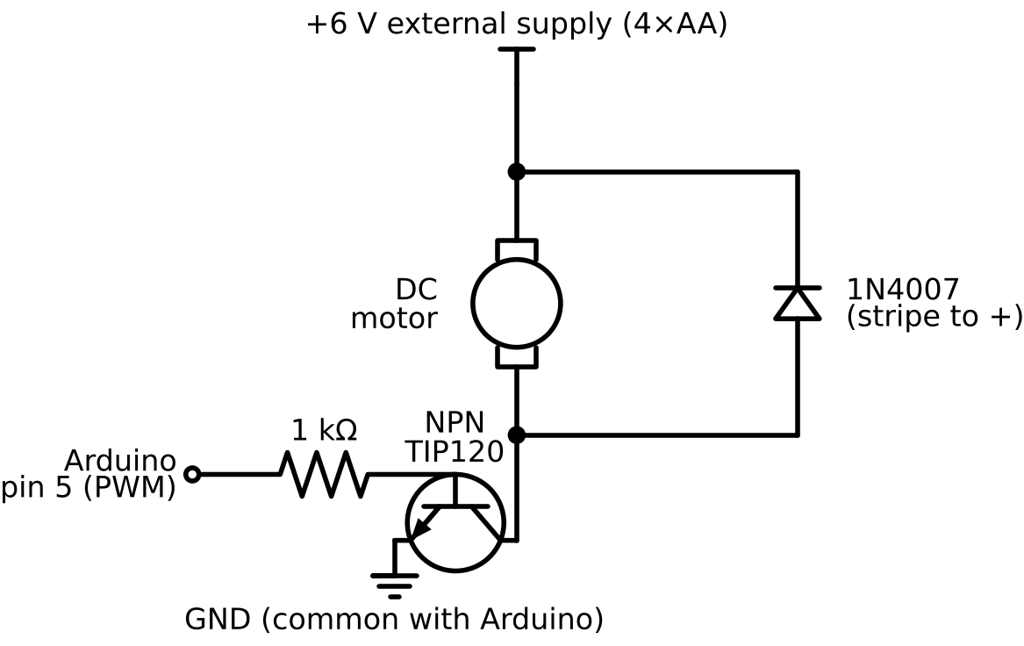
Figure 6.1: Low-side NPN transistor motor driver with flyback diode and separate motor supply.
Component | Role | If Omitted
NPN transistor (TIP120) | Switches the motor current | Pin overloaded; board damaged
1 kΩ base resistor | Limits current from the pin | Excess pin current
1N4007 flyback diode | Absorbs back-EMF spikes | Transistor and board damaged over time
External supply | Provides motor current | Board resets (brownout)
Common ground | Shared voltage reference | Motor never turns

For forward and reverse control, an H-bridge driver such as the L293D, L9110S or TB6612FNG replaces the single transistor.

6.2 Motor Speed with PWM
The PWM duty cycle from Section 5 sets the average voltage across the motor, and therefore its speed. Motors have a dead zone: below roughly 30 – 40 % duty they hum but do not turn, so useful speeds are mapped to a range starting at a minimum duty. Changing speed gradually (ramping) — a few steps every 10 ms using millis() — reduces current spikes and mechanical wear, exactly as industrial motor drives do.

6.3 Finite-State Machines
As behaviour grows, scattered if-statements become impossible to debug. A finite-state machine (FSM) describes a system as a set of states (what it is doing) and transitions (rules for moving between states). It is implemented with an enum and a switch in loop(). Hysteresis — entering OVERHEAT at 40 °C but leaving only below 35 °C — prevents the system from flickering rapidly between two states.
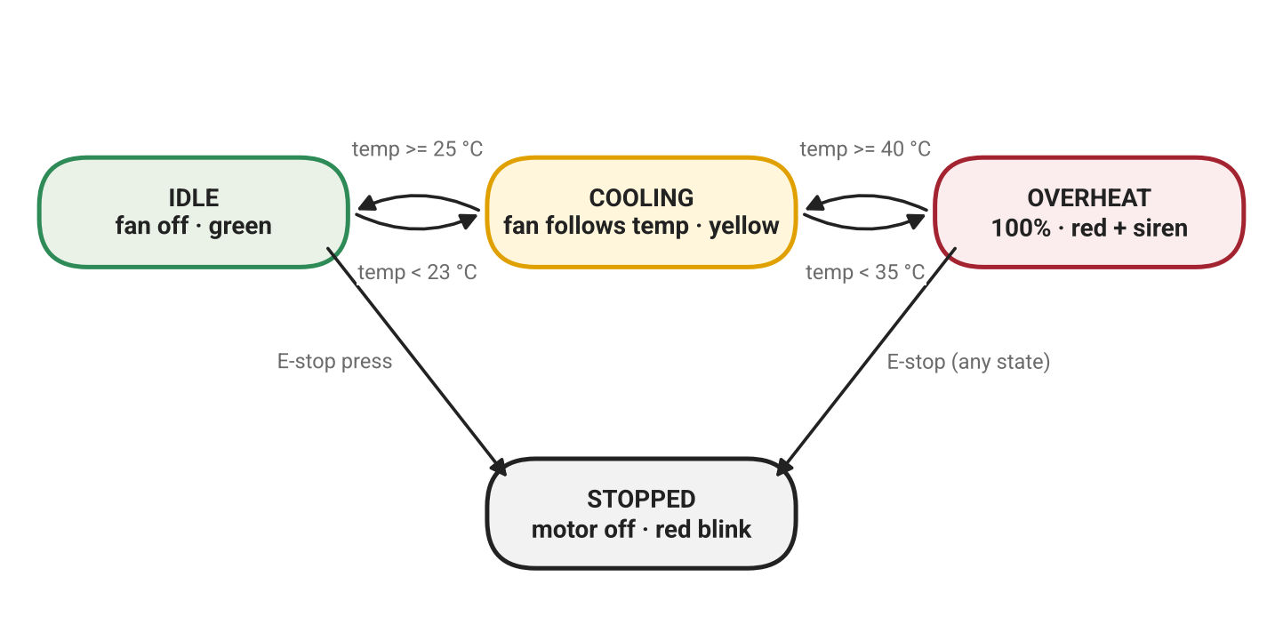
Figure 6.2: State diagram of the Smart Fan built in Lab 6, including hysteresis and emergency stop.

6.4 Integration & Testing
Integration is where most bugs appear. Add one subsystem at a time — inputs, state machine, LEDs, motor, buzzer — testing and committing after each. Every requirement receives a written test, for example: “pressing E-stop in any state stops the motor within 100 ms”.

6.5 Common Mistakes
Mistake | What Happens | How to Avoid
Motor powered from 5V pin | Board resets | Use an external supply
No common ground | Motor does not turn | Join supply GND and Arduino GND
Diode reversed | Supply short-circuited | Stripe toward +V
Duty below dead zone | Motor hums, no motion | Start at MIN_DUTY or kick-start
Motor on pin 3 or 11 | Stutters when buzzer sounds | Keep the motor on pin 5

Lab Exercise 6: Smart Fan (Guided Project)
Objective
To build a temperature-controlled fan that drives a DC motor safely, varies its speed with PWM, shows status on LEDs, sounds an overheat alarm and supports an emergency stop — all organised as a finite-state machine.
Hardware Required
- Arduino Uno and breadboard
- DC motor, TIP120 (or 2N2222), 1 kΩ resistor, 1N4007 diode, 4×AA battery pack
- 10 kΩ potentiometer (simulated temperature 0 – 50 °C)
- Push button (E-stop), passive buzzer, green/yellow/red LEDs with 220 Ω resistors
Circuit Connections
Component | Arduino Pin
Motor driver (transistor base via 1 kΩ) | D5 (PWM)
Potentiometer wiper | A0
E-stop button (to GND) | D2
Green / Yellow / Red LEDs | D6 / D9 / D10
Passive buzzer | D7
Working Principle
The potentiometer simulates a temperature sensor. In IDLE the fan is off; in COOLING its speed rises with temperature; in OVERHEAT it runs at full speed with a siren. The E-stop toggles a STOPPED state from any state. A non-blocking ramp changes motor speed smoothly, and temperature, duty and state are streamed to the Serial Plotter.
Procedure
- Build the motor driver circuit of Figure 6.1. Have the instructor check the wiring before connecting power (safety sign-off).
- Upload the program and open the Serial Plotter.
- Turn the potentiometer and confirm the fan stays off below 25 °C and ramps up between 25 °C and 40 °C.
- Exceed 40 °C and confirm full speed, red blink and siren; confirm the alarm clears only below 35 °C.
- Press the E-stop in every state and confirm the motor stops within 100 ms.
- Tune MIN_DUTY to the dead zone of your motor.
- Write six test cases and record pass/fail for each.
Program Code
// Lab 6: Smart Fan - FSM + PWM motor + non-blocking alarm
const int MOTOR = 5, TEMP_POT = A0, ESTOP = 2;
const int LED_G = 6, LED_Y = 9, LED_R = 10, BUZZER = 7;
const float COOL_ON = 25.0, HOT_ON = 40.0, HOT_OFF = 35.0;
const int MIN_DUTY = 90; // tune to your motor's dead zone

enum State { IDLE, COOLING, OVERHEAT, STOPPED };
State state = IDLE;
int currentDuty = 0;
unsigned long lastRamp = 0, lastAlarm = 0, lastLog = 0;
bool alarmTone = false, lastBtn = HIGH;

float readTempC() { return analogRead(TEMP_POT) * 50.0 / 1023.0; }

void setLeds(bool g, bool y, bool r) {
digitalWrite(LED_G, g); digitalWrite(LED_Y, y); digitalWrite(LED_R, r);
}

void rampMotor(int target, unsigned long now) { // non-blocking ramp
if (now - lastRamp >= 10) {
lastRamp = now;
if (currentDuty < target) currentDuty = min(currentDuty + 5, target);
if (currentDuty > target) currentDuty = max(currentDuty - 5, target);
analogWrite(MOTOR, currentDuty);
}
}

void alarm(unsigned long now) {
if (now - lastAlarm >= 250) {
lastAlarm = now;
alarmTone = !alarmTone;
tone(BUZZER, alarmTone ? 1200 : 800);
digitalWrite(LED_R, alarmTone);
}
}

bool estopPressed() { // edge detect
bool b = digitalRead(ESTOP);
bool pressed = (lastBtn == HIGH && b == LOW);
lastBtn = b;
return pressed;
}

void setup() {
pinMode(MOTOR, OUTPUT); pinMode(ESTOP, INPUT_PULLUP);
pinMode(LED_G, OUTPUT); pinMode(LED_Y, OUTPUT); pinMode(LED_R, OUTPUT);
Serial.begin(115200);
Serial.println(F("Smart Fan ready"));
}

void loop() {
unsigned long now = millis();
float t = readTempC();

if (estopPressed()) {
state = (state == STOPPED) ? IDLE : STOPPED;
noTone(BUZZER);
Serial.println(state == STOPPED ? F("E-STOP") : F("Resumed"));
}

switch (state) {
case IDLE:
setLeds(1, 0, 0); rampMotor(0, now);
if (t >= COOL_ON) state = COOLING;
break;
case COOLING: {
setLeds(0, 1, 0);
int target = map((int)t, (int)COOL_ON, (int)HOT_ON, MIN_DUTY, 255);
rampMotor(constrain(target, MIN_DUTY, 255), now);
if (t >= HOT_ON) state = OVERHEAT;
else if (t < COOL_ON - 2) state = IDLE; // small hysteresis
break;
}
case OVERHEAT:
digitalWrite(LED_G, 0); digitalWrite(LED_Y, 0);
rampMotor(255, now); alarm(now);
if (t < HOT_OFF) { state = COOLING; noTone(BUZZER); }
break;
case STOPPED:
currentDuty = 0; analogWrite(MOTOR, 0); // immediate stop
setLeds(0, 0, (now / 500) % 2); // slow red blink
break;
}

if (now - lastLog >= 250) { // Serial Plotter
lastLog = now;
Serial.print(F("temp:")); Serial.print(t, 1);
Serial.print(F(" duty:")); Serial.print(currentDuty);
Serial.print(F(" state:")); Serial.println(state * 10);
}
}
Expected Output
Green LED and stationary fan at low temperature; yellow LED and a fan that speeds up smoothly as the potentiometer is turned; red flashing LED, full-speed fan and two-tone siren above 40 °C. The E-stop immediately stops the motor and blinks red slowly. The Serial Plotter shows the temperature, duty and state curves together.
Observation
Without hysteresis the alarm chatters on and off near 40 °C; with the 35 °C exit threshold it switches cleanly. If the board resets each time the motor starts, the motor is drawing current from the Arduino’s 5V pin (brownout) — an external supply with a common ground fixes it.
Conclusion
The learner can drive an inductive load safely and structure behaviour as a state machine. The fan module and FSM core are merged into SmartAlert with the states NORMAL, WARNING, FAULT and MAINTENANCE.
Assessment Rubric (30 points)
Criterion | Points
Safe wiring (driver, diode, common ground) | 8
State machine correctness | 8
Non-blocking behaviour | 6
Code readability | 4
Test log | 4

Quick Check
- What does the flyback diode protect against, and which way does its stripe face?
- Why might a motor not spin at analogWrite(pin, 50)?
- Why enter OVERHEAT at 40 °C but leave it at 35 °C?
- The motor stutters only when the buzzer sounds. What is the first thing to check?

7. Independent Engineering Challenges
In this section the step-by-step guidance is removed. Each challenge provides only a specification, a pin map and acceptance tests — exactly how real engineering work arrives. Learners complete three of the five challenges, test them and review a peer’s code.

7.1 Reading a Requirements Specification
Before writing any code: read the spec → list inputs and outputs → sketch the state diagram → assign pins → write acceptance tests in the form “Given … When … Then …”. Requirements written with shall are mandatory; should marks a desirable extra. A vague requirement such as “the alarm should be fast” must be rewritten as a testable one: “the alarm shall sound within 100 ms of the button press”.

7.2 A Systematic Debugging Method — REPAIR
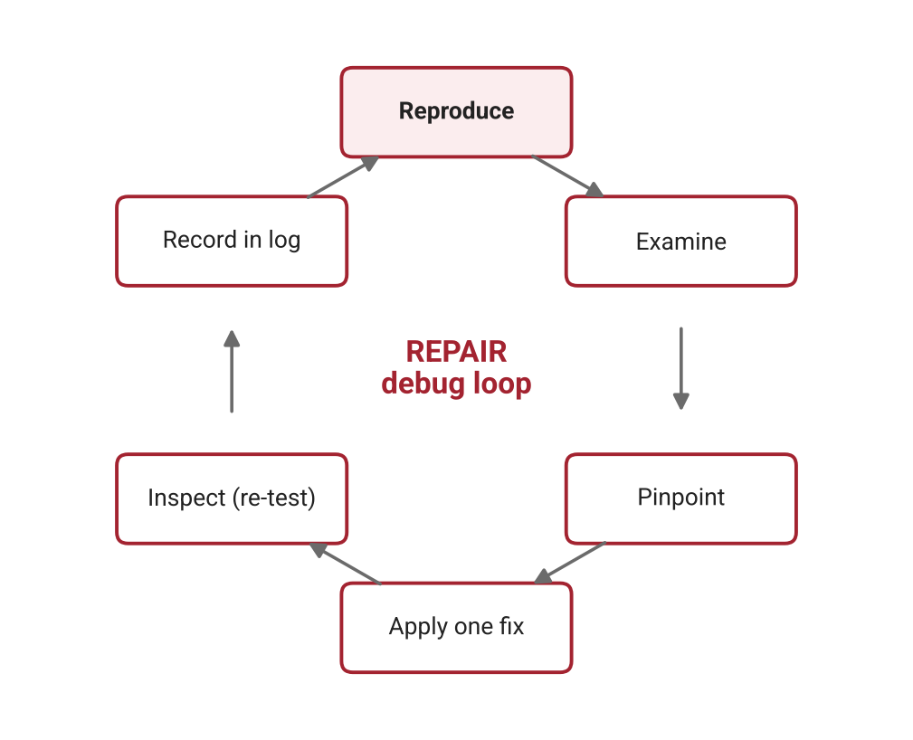
Figure 7.1: The REPAIR debugging loop used in every Debug Clinic.
- Reproduce the bug reliably before changing anything.
- Examine the Serial output and the wiring.
- Pinpoint the cause by halving — test subsystems alone or comment out half the code.
- Apply one fix at a time.
- Inspect — re-run every test, not only the one that failed (avoid regressions).
- Record symptom → cause → fix in the engineering log.
Tip: if a sketch works in the simulator but not on hardware, suspect the wiring first.

7.3 Challenge Sprint (choose 3 of 5)
Challenge | Specification Summary | Key Acceptance Tests
Reaction Timer Game | After a random 2–5 s wait the LED lights; the player presses the button and the reaction time in ms is printed. Early press = “Too soon!” + low buzz. Best of 5 stored. | Early press detected; time accurate to ±5 ms; best score updates
Morse Beacon | Type a word in Serial; it is blinked and beeped in Morse (dot 200 ms, dash 600 ms) without blocking. A new word interrupts. | Correct for SOS and HELLO; interrupt within 50 ms
Plant-Water Pump (sim) | Pot = soil moisture. Below 30 % run the pump (motor) for 3 s, then wait 10 s before re-checking. Manual-water button. | Never runs > 3 s per cycle; lockout respected
Parking Sensor (sim) | Pot = distance 0–200 cm. Beep interval shrinks as distance falls; below 20 cm continuous tone + red LED. | Correct zone at 20, 50 and 100 cm
Serial Menu Controller | Commands such as L 75, M 40, B 1 control LED brightness, motor speed and buzzer; invalid input gives a helpful error. | All commands work; out-of-range rejected

Starter Skeleton — Reaction Timer (the only scaffold provided)
// Challenge 1: Reaction Timer - complete the TODOs
const int LED = 8, BUTTON = 2, BUZZER = 7;
enum State { WAITING, READY, LIT, RESULT };
State state = WAITING;
unsigned long stateStart = 0, waitTime = 0, best = 0xFFFFFFFF;

void setup() {
pinMode(LED, OUTPUT); pinMode(BUTTON, INPUT_PULLUP);
Serial.begin(115200);
randomSeed(analogRead(A5)); // floating pin = random seed
}

void loop() {
unsigned long now = millis();
bool pressed = digitalRead(BUTTON) == LOW;
switch (state) {
case WAITING: // TODO: print "Get ready", choose waitTime 2000-5000, go to READY
break;
case READY: // TODO: if pressed -> "Too soon!" + low buzz -> WAITING
// TODO: if waited long enough -> LED on -> LIT
break;
case LIT: // TODO: if pressed -> compute reaction, update best -> RESULT
break;
case RESULT: // TODO: show result for 2 s, wait for release -> WAITING
break;
}
}
Peer Review Checklist (1 point each)
- Pins, timings and thresholds are named constants.
- No delay() longer than 20 ms in loop().
- All time variables are unsigned long.
- Each function has one clear responsibility.
- Comments explain why, not what.
- Every acceptance test is logged with pass/fail.
- README includes a wiring table.

8. Capstone — SmartAlert Station

8.1 Project Scenario & Requirements
A small fabrication workshop runs a 3D printer and a laser cutter inside an enclosure. The owner needs a low-cost station that shows the enclosure’s status at a glance, cools it automatically, raises an alarm on overheating or a manual fault signal, and can be checked and controlled from a laptop. As the embedded developer, the learner integrates every skill from Sections 1–7 into the SmartAlert Station.
ID | Requirement | Verified By
R1 | Show NORMAL (green solid), WARNING (yellow blink), FAULT (red fast blink), MAINTENANCE (yellow slow blink) | Visual test
R2 | Enter WARNING at ≥ 30 °C; return to NORMAL below 28 °C | Pot sweep
R3 | Enter FAULT at ≥ 45 °C or on fault-button press | Two triggers
R4 | Sound a siren in FAULT until acknowledged; leave only when acknowledged AND < 40 °C | Sequence test
R5 | Fan off / proportional / 100 % by state, always ramped | Plotter trace
R6 | Serial commands: s status, m mute 60 s, a acknowledge, x maintenance, f0–f100 manual fan, ? help | Command test
R7 | Log every state change as [EVENT] OLD -> NEW | Log review
R8 | Stream temp, fan and mode to the Serial Plotter every 500 ms | Screenshot
R9 | No delay() in loop(); button response under 50 ms | Code review
R10 | Motor driven via transistor with flyback diode and common ground | Wiring inspection

8.2 System Architecture
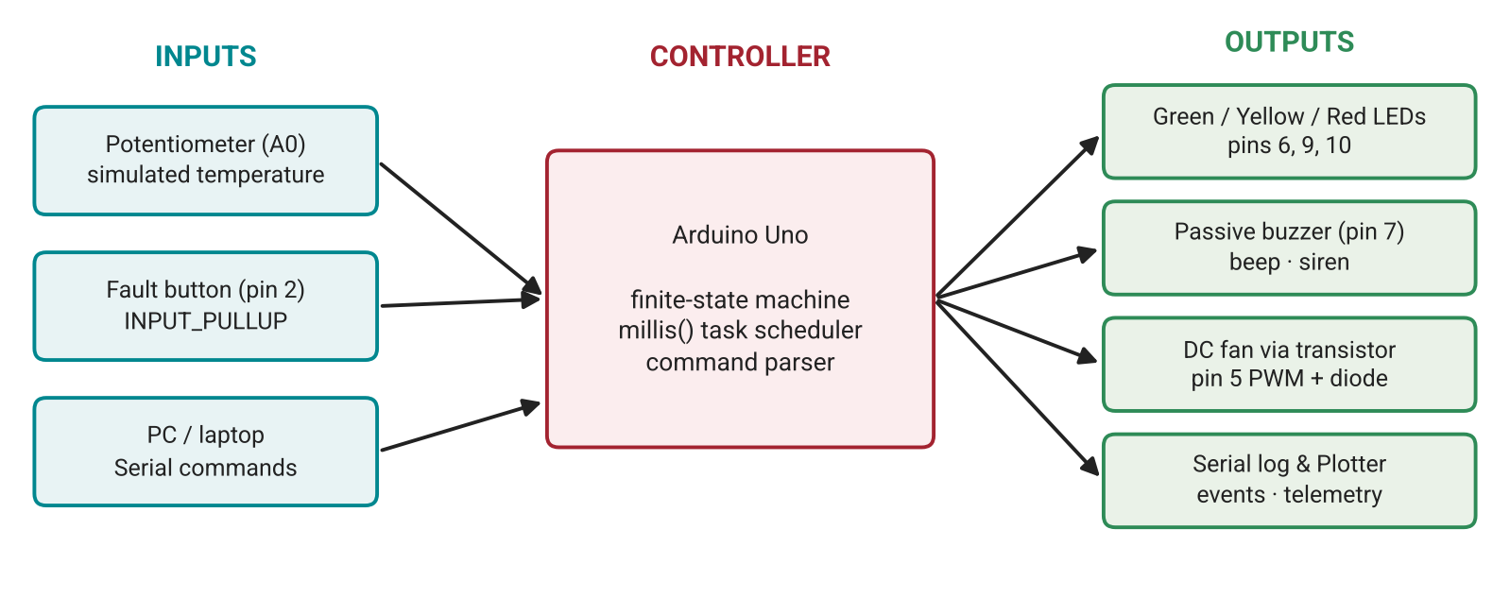
Figure 8.1: SmartAlert Station architecture — inputs, controller logic and outputs.
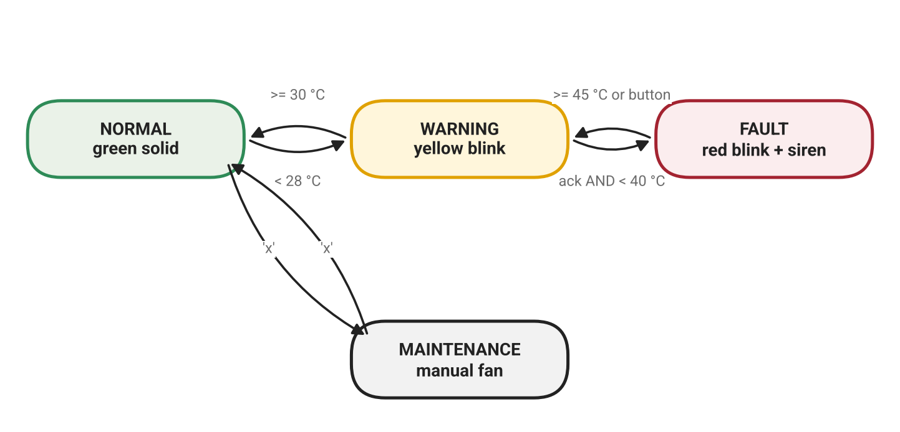
Figure 8.2: SmartAlert operating states and transitions.

Lab Exercise 8: Building and Testing the SmartAlert Station
Objective
To integrate LED, buzzer and DC motor control with a state machine, non-blocking timing and a serial command interface into one tested, documented embedded product.
Hardware Required
- All components from Lab 6 (motor driver, potentiometer, button, 3 LEDs, passive buzzer)
Software Required
- Arduino IDE 2.x (Serial Monitor and Plotter)
- Wokwi
- Git and GitHub
Procedure
- Integrate in this order, committing after each step: inputs → state machine (Serial events only) → LEDs → fan → buzzer → commands → telemetry.
- Run the full R1–R10 test table and record pass/fail with timestamps.
- Test edge cases: fault during maintenance, mute during a fault, button held down.
- Capture a Serial Plotter screenshot of a full warm-up and cool-down cycle.
- Complete the README, wiring diagram and state diagram, and tag the release v1.0.
- Record a 2–3 minute demo video and prepare the pitch.
Program Code (Reference Solution)
// SmartAlert Station v1.0 - capstone reference solution
// ---------- configuration ----------
const int PIN_TEMP = A0, PIN_FAULT_BTN = 2;
const int PIN_LED_G = 6, PIN_LED_Y = 9, PIN_LED_R = 10;
const int PIN_BUZZER = 7, PIN_MOTOR = 5;
const float WARN_ON = 30.0, WARN_OFF = 28.0, FAULT_ON = 45.0, FAULT_CLEAR = 40.0;
const int MIN_DUTY = 90;
const unsigned long MUTE_MS = 60000UL;

enum Mode { NORMAL, WARNING, FAULT, MAINTENANCE };
const char* const MODE_NAMES[] = {"NORMAL", "WARNING", "FAULT", "MAINTENANCE"};
Mode mode = NORMAL;

float tempC = 0;
int fanDuty = 0, fanTarget = 0, manualDuty = 0;
bool acknowledged = false, muted = false, sirenHigh = false, lastBtn = HIGH;
unsigned long muteStart = 0, lastRamp = 0, lastBeep = 0, lastSiren = 0;
unsigned long lastLog = 0, lastBtnChange = 0;

// ---------- inputs ----------
float readTemp() { return analogRead(PIN_TEMP) * 50.0 / 1023.0; }

bool faultButtonPressed(unsigned long now) { // debounced edge
bool b = digitalRead(PIN_FAULT_BTN);
if (b != lastBtn && now - lastBtnChange > 30) {
lastBtnChange = now;
lastBtn = b;
return b == LOW;
}
return false;
}

// ---------- helpers ----------
bool blink(unsigned long now, unsigned long period) { return (now / period) % 2; }

void setLeds(bool g, bool y, bool r) {
digitalWrite(PIN_LED_G, g); digitalWrite(PIN_LED_Y, y); digitalWrite(PIN_LED_R, r);
}

void setMode(Mode m) {
if (m == mode) return;
Serial.print(F("[EVENT] ")); Serial.print(MODE_NAMES[mode]);
Serial.print(F(" -> ")); Serial.println(MODE_NAMES[m]);
mode = m;
noTone(PIN_BUZZER);
if (m == FAULT) acknowledged = false;
}

void printStatus() {
Serial.print(F("[STATUS] mode=")); Serial.print(MODE_NAMES[mode]);
Serial.print(F(" temp=")); Serial.print(tempC, 1);
Serial.print(F(" fan=")); Serial.print(fanDuty * 100 / 255); Serial.print('%');
Serial.print(F(" muted=")); Serial.println(muted ? F("yes") : F("no"));
}

void printHelp() {
Serial.println(F("s=status m=mute a=ack x=maintenance f<0-100>=fan ?=help"));
}

// ---------- serial commands ----------
void handleSerial(unsigned long now) {
if (!Serial.available()) return;
char c = Serial.read();
switch (c) {
case 's': printStatus(); break;
case 'm': muted = true; muteStart = now; noTone(PIN_BUZZER);
Serial.println(F("Muted for 60 s")); break;
case 'a': acknowledged = true; Serial.println(F("Fault acknowledged")); break;
case 'x': setMode(mode == MAINTENANCE ? NORMAL : MAINTENANCE); break;
case 'f': manualDuty = constrain(Serial.parseInt(), 0, 100) * 255 / 100;
Serial.print(F("Manual fan duty: ")); Serial.println(manualDuty); break;
case '?': printHelp(); break;
case '\n': case '\r': break;
default: Serial.println(F("Unknown command - type ?"));
}
}

// ---------- state machine ----------
void updateMode(unsigned long now) {
bool btn = faultButtonPressed(now);
switch (mode) {
case NORMAL:
if (btn || tempC >= FAULT_ON) setMode(FAULT);
else if (tempC >= WARN_ON) setMode(WARNING);
break;
case WARNING:
if (btn || tempC >= FAULT_ON) setMode(FAULT);
else if (tempC < WARN_OFF) setMode(NORMAL);
break;
case FAULT:
if (btn) { acknowledged = true; Serial.println(F("Fault acknowledged")); }
if (acknowledged && tempC < FAULT_CLEAR) setMode(tempC >= WARN_ON ? WARNING : NORMAL);
break;
case MAINTENANCE:
break; // leaves only via 'x'
}
}

// ---------- outputs ----------
void siren(unsigned long now) {
if (now - lastSiren >= 250) {
lastSiren = now; sirenHigh = !sirenHigh;
tone(PIN_BUZZER, sirenHigh ? 1200 : 800);
}
}

void rampFan(unsigned long now) {
if (now - lastRamp >= 10) {
lastRamp = now;
if (fanDuty < fanTarget) fanDuty = min(fanDuty + 5, fanTarget);
if (fanDuty > fanTarget) fanDuty = max(fanDuty - 5, fanTarget);
analogWrite(PIN_MOTOR, fanDuty);
}
}

void updateOutputs(unsigned long now) {
if (muted && now - muteStart >= MUTE_MS) muted = false;
switch (mode) {
case NORMAL:
setLeds(1, 0, 0); fanTarget = 0;
break;
case WARNING:
setLeds(0, blink(now, 500), 0);
fanTarget = constrain(map((int)tempC, (int)WARN_ON, (int)FAULT_ON, MIN_DUTY, 255), MIN_DUTY, 255);
if (!muted && now - lastBeep >= 5000) { lastBeep = now; tone(PIN_BUZZER, 1000, 100); }
break;
case FAULT:
setLeds(0, 0, blink(now, 150)); fanTarget = 255;
if (!muted && !acknowledged) siren(now); else noTone(PIN_BUZZER);
break;
case MAINTENANCE:
setLeds(0, blink(now, 1000), 0); fanTarget = manualDuty;
break;
}
rampFan(now);
}

void logTelemetry(unsigned long now) { // Serial Plotter format
if (now - lastLog >= 500) {
lastLog = now;
Serial.print(F("temp:")); Serial.print(tempC, 1);
Serial.print(F(" fan:")); Serial.print(fanDuty * 100 / 255);
Serial.print(F(" mode:")); Serial.println(mode * 10);
}
}

// ---------- main ----------
void setup() {
pinMode(PIN_FAULT_BTN, INPUT_PULLUP);
pinMode(PIN_LED_G, OUTPUT); pinMode(PIN_LED_Y, OUTPUT); pinMode(PIN_LED_R, OUTPUT);
pinMode(PIN_MOTOR, OUTPUT);
Serial.begin(115200);
Serial.setTimeout(50); // keep parseInt() short
Serial.println(F("=== SmartAlert Station v1.0 ==="));
printHelp();
}

void loop() {
unsigned long now = millis();
tempC = readTemp();
handleSerial(now);
updateMode(now);
updateOutputs(now);
logTelemetry(now);
}
Expected Output
As the simulated temperature rises, the station moves NORMAL → WARNING → FAULT, printing an [EVENT] line at each change. The fan speeds up in WARNING and runs at 100 % in FAULT; the siren sounds until the fault is acknowledged, and the station returns to WARNING once the temperature falls below 40 °C.
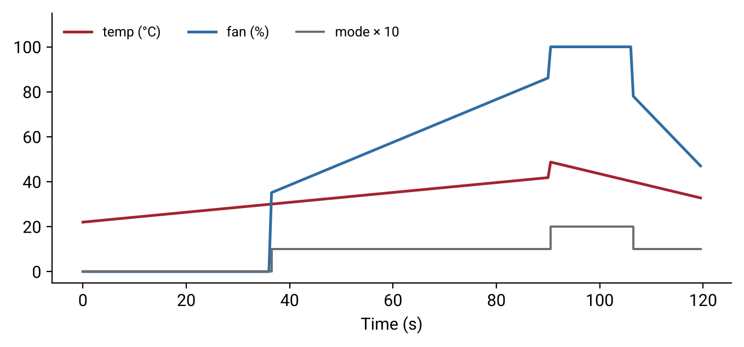
Figure 8.3: Serial Plotter telemetry from a full warm-up and cool-down cycle of the SmartAlert Station.
Observation
The ramped fan curve contains no sudden jumps, the mode trace steps cleanly without chattering thanks to hysteresis, and every serial command responds immediately because no part of the program blocks.
Conclusion
The SmartAlert Station demonstrates the complete skill set of this module — program structure, data types, conditions, loops, Serial communication and safe control of an LED, a buzzer and a DC motor — packaged as a tested product ready for a portfolio.

8.3 Documentation & Presentation
- README — problem, demo video link, features, bill of materials, wiring table and diagram, how to upload, serial command reference, state diagram, test results, known limitations, next steps.
- Git history — at least 10 meaningful commits in imperative form (“Add fan ramping”) and a v1.0 tag.
- Demo video (2–3 min) — problem (15 s), walk through every state (60 s), Serial console and Plotter (30 s), one design decision (30 s), one bug you fixed (30 s).

8.4 Where Next — IoT, Edge AI & Vision-Triggered Control
In modern systems, a camera and an AI model detect, and a microcontroller acts. Because SmartAlert already accepts serial commands, a vision program on a PC can control it. The optional stretch task below uses OpenCV person detection to send v (person detected) or n (clear); learners add matching cases to handleSerial() that switch SmartAlert to WARNING.
# vision_trigger.py - stretch: webcam person detection -> SmartAlert
# pip install opencv-python pyserial
import cv2, serial, time

ser = serial.Serial("COM5", 115200, timeout=0.1) # /dev/ttyACM0 on Linux
time.sleep(2) # Uno resets when port opens
hog = cv2.HOGDescriptor()
hog.setSVMDetector(cv2.HOGDescriptor_getDefaultPeopleDetector())
cam = cv2.VideoCapture(0)

while True:
ok, frame = cam.read()
if not ok:
break
small = cv2.resize(frame, (320, 240))
boxes, _ = hog.detectMultiScale(small, winStride=(8, 8))
ser.write(b"v" if len(boxes) else b"n") # tell SmartAlert
for (x, y, w, h) in boxes:
cv2.rectangle(small, (x, y), (x + w, y + h), (0, 255, 0), 2)
cv2.imshow("SmartAlert vision", small)
if cv2.waitKey(200) & 0xFF == ord("q"):
break

cam.release(); ser.close(); cv2.destroyAllWindows()

8.5 Capstone Assessment Rubric (100 points)
Criterion | Points | Full Marks Means
Functional requirements R1–R8 | 35 | All pass, with a test log
Non-blocking design & code quality (R9) | 15 | No delay(), named constants, single-purpose functions
Hardware safety (R10) | 10 | Driver, diode, common ground, external supply
Testing evidence | 10 | ≥ 12 tests including edge cases
Documentation & Git | 15 | Complete README, diagrams, ≥ 10 commits, v1.0 tag
Demo video & pitch | 10 | Under 3 min; explains one decision and one bug
Engineering log reflection | 5 | Debug Clinic entries with root causes
Stretch: vision trigger (bonus) | +5 | Working person-detection demo

Passing score: 70. Distinction: 90 and above.

8.6 Module Assessment Summary
Component | Weight | Format
Section quizzes (1–5) | 15 % | Auto-graded, includes code tracing
Debug Clinics | 10 % | Symptom → cause → fix log
Labs & mini-projects | 20 % | Simulator link + hardware video
Guided project — Smart Fan | 15 % | 30-point rubric + safety sign-off
Independent challenges | 10 % | Auto-tests + peer review
Capstone — SmartAlert Station | 30 % | 100-point rubric + presentation

